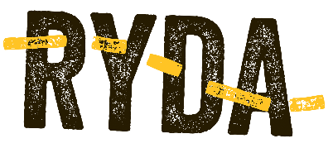

What is your car trying to tell you?
Extending your RYDA road skills

Have you ever wondered what all those little symbols on your car dashboard mean? You know, the ones that light up like Times Square every time you switch on the ignition. Ever got one while you’re in the middle of traffic and panicked because you thought your car might blow up?

Some of them are actually pretty important because they could be telling you that there is an issue you need to tend to.

We’ve gathered a few of the common ones (and a few quirky ones too) to challenge you. Your job is to find out what they mean and what you should do about them.

Here’s what to do:
- Grab the manual from the glovebox of your car (or your family car)
- See if you can find as many of these symbols as possible, using your manual as your resource tool, and fill in the table below
- Do a deep dive on Google to help you work out the rest. Different cars have different features so they may not all be in your manual.
- We’ve helped you by ruling out one possibility for each. You’re welcome.
- Don’t forget to put the manual back in the glovebox when you’re done.

Note: Your car’s warning lights may vary and the symbols listed below may have altered designs and colours. Make sure you know what they look like on your car.

Warning Light | Hint: It’s NOT this…. | What is it trying to tell you? | What do you need to do?
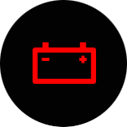 | Awww, cute little robot just winked at me!
 | There’s a Pokemon gym nearby
 | Give up! That key’s never gunna fit in that hole!
 | There’s a box of chocolates hidden in your muffler
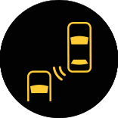 | Our phones are in range
 | A child has fallen down a well
 | My passenger just blew a huge bubble
 | Watch out – whales up ahead
 | Sweet, there’s a Macca’s over that hill
 | Naww, I think my car is asking me out
 | Worms are eating your lights!
 | ♪♬ “We all live in a yellow submarine ♫
 | Your neti pot is leaking
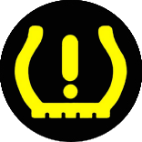 | Your witches caldron is empty
 | There’s a collectable coin nearby
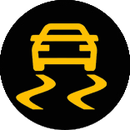 | Looks like you might have run over some snakes back there
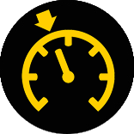 | Time to go home, Cinderella
 | The water’s perfect, dive in!
 | Stick your hand through this hole and collect an egg
 | Congratulations, you found the steering wheel!
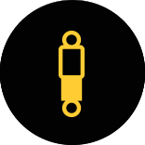 | Your glowstick is halfway burned out!
 | Drop and give me 5 sit-ups.
 | Good news, your key is connected to wi-fi

